ISB DX Interface Design

ITSO
Administrative Office of the Courts, CA

June, 2013

Table of Contents

1.1 ISB Common Service Header 4

Document Version History Table

Version Number | Date Submitted | Comments
1.0 | 06/06/2013 | Initial release

ISB Common Service Header

The common header for all services is shown below.

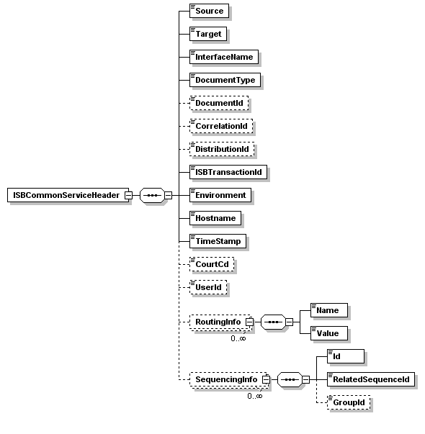

Field Name | Required? | Value | Description
Source | Y | 1200000000 | The Source application for this transaction
Target | Y | 1020000000 | The target application for this transaction. If there are multiple targets then an alias will be used.
InterfaceName | Y | DSP917 | The Interface name application for this transaction
DocumentType | Y | DSP917 | The Document type application for this transaction
DocumentId | N |  | The document id application for this transaction
CorrelationId | N | FACCTS ID | The correlation id for this transaction. This id if provided by the source application can be used to trace the transaction end-to-end.
DistributionId | N |  | In the event of a fan-out this id will be used to keep track of the different paths
ISBTransactionId | Y | -1 | This id is used by the ISB to track a transaction within the ISB. Use minus one (-1) for ISB to assign a transaction ID.
Environment | Y |  | The environment (e.g. DEV, TEST, PROD) from which this service is being invoked
Hostname | Y |  | The machine from which this service is being invoked
TimeStamp | Y |  | The timestamp for this transaction from the invoking application.
CourtCd | Y |  | Court code
UserId | Y |  | Either system or person user name.
RoutingInfo/Name &  RoutingInfo/Value | N |  | These elements will be used to provide the information required for content based routing.
SequenceInfo/Id | N |  | The sequencing id for this transaction. The source application should provide this information If strict sequencing is required.
SequenceInfo/RelatedSequenceId | N |  | The related sequencing id for this transaction. The source application should provide this information If strict sequencing is required.
SequenceInfo/GroupId | N |  | The sequencing group id for this transaction. The source application should provide this information If strict sequencing is required.

Note: The CourtCd and UserId are new attributes added to the ISB Common Service Header. CourtCd is needed because every action in CCMS is executed under context of court code. UserId information is needed for auditing purpose as per AOC auditing requirements. UserId can be the system id or the actual user id.

Sample Message

<tnshdr:ISBCommonServiceHeader>
<Source>1200000000</Source>
<Target>1020000000</Target>
<InterfaceName>DSP917</InterfaceName>
<DocumentType>DSP917</DocumentType>

<CorrelationId>130000217092</CorrelationId>
<DistributionId>1</DistributionId>
<ISBTransactionId>1002968903</ISBTransactionId>
<Environment>TEST</Environment>
<Hostname>localhost</Hostname>
<TimeStamp>2011-02-03T21:56:52.285-05:00</TimeStamp>
<CourtCd>13</CourtCd>

<RoutingInfo>
<Name>Court</Name>
<Value>13</Value>
</RoutingInfo>
<RoutingInfo>
<Name>InterfaceName</Name>
<Value>DSP917</Value>
</RoutingInfo>
<SequencingInfo>
<Id>1</Id>
<RelatedSequenceId>-1</RelatedSequenceId>
<GroupId>130003444229</GroupId>
</SequencingInfo>
</tnshdr:ISBCommonServiceHeader>

